How to update the firmware of Powerline Extender?
Step 1: Open the browser and input plc.tendawifi.com in address bar to login setup page. By default, password is “admin”.
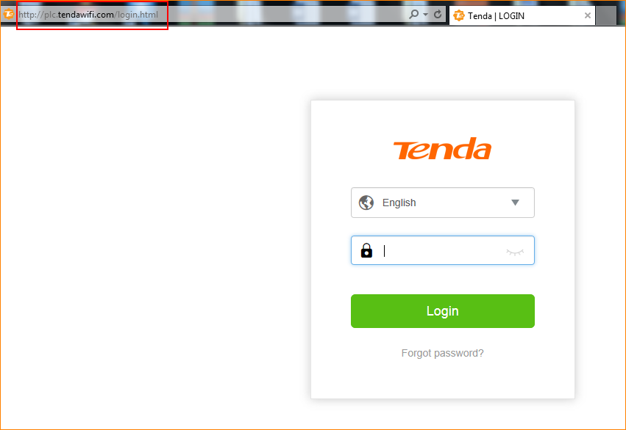
Step 2: Choose “System” > “Firmware Upgrade”.
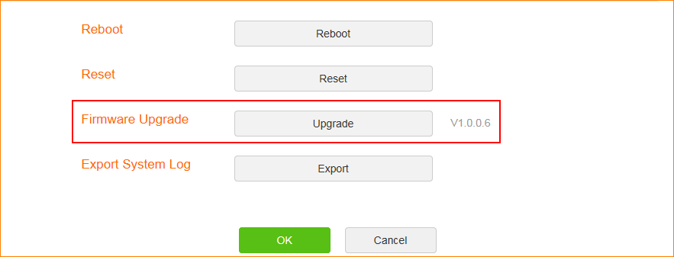
Step 3: You can choose “Online Upgrade” or “Local Upgrade”.
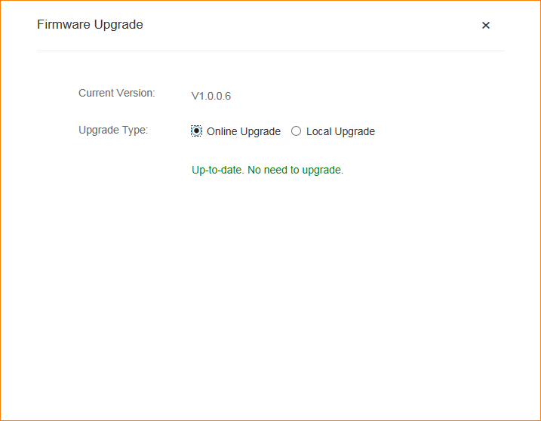
Note: If you choose “Local Upgrade”, please download the firmware form Tenda official website. Tap “Select” to upload the firmware from your PC. Please reset the PLC after upgrade is finished.
